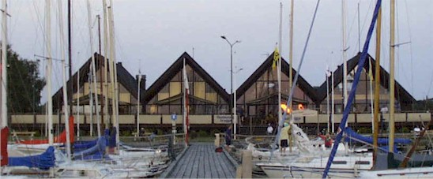

Proposal

for the 48:th World 505 Championship
& International Swedish Championship

Malmö Segelsällskap MSS

- SWEDEN July/August 2003 -



Swedish 505 Association
Some facts about MSS – Malmö Segel Sällskap

- MSS was founded 1876 and is situated 6 km southwest downtown Malmoe. MSS has hosted many International regattas, most recently the worlds for H-boats.

- MSS marina hosts appr. 1.100 boats and 3 sailing clubs. MSS is the ”regattaclub” and one of the official olympic training centers in Sweden (MSS had 3 participants in the Sydney olympics).

- MSS has a big clubhouse and all the facilities that can be expected from a 505 worlds point of view. There are 4 slipways, cemented boatparking (no sand). 16 showers, a big and fully licensed restaurant with outdoor veranda towards the harbour.

- MSS is also perfect for the family, a nearby leisure beach (300m), close to Limhamns city centre (500m) and the 2 International cities Malmoe (10 minutes) and Copenhagen (30 minutes) away. Buses to the city and connecting trains to Copenhagen are only 2 minutes (walking distance) from the club. Copenhagen International airport is reached within 25 minutes by car and 20 minutes with bus/train.

- There is camping facility nearby (500 m) with cottages and space for own tents. Hotels and youth hostel is also available at biking distance (1-3 km).

- Sailing will be at the sound (Öresund) between Denmark and Sweden, close to the new bridge between Sweden and Denmark.

- For more information please also visit http://mss.m.se/ were the 2003 Worlds homepage will be located.

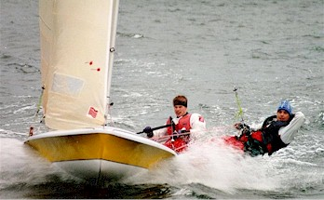 | 